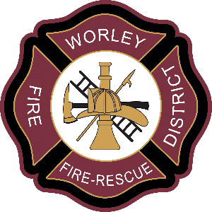
WORLEY FIRE DISTRICT
31541 SOUTH HIGHWAY 95
WORLEY, IDAHO 83876

NOTICE IS HEREBY GIVEN that Regular Board Meetings of the Worley Fire Protection District in Worley, Idaho will be held on the last Tuesday of each month at 4:30 p.m. unless otherwise noted. The meetings will be held at Worley Fire Station 1.

MONTH | DATE | LOCATION | COMMENTS
January | 28 | Worley Fire Station 1 | @ 5:30 pm
February | 25 | Worley Fire Station 1 | @ 5:30 pm
March | 25 | Worley Fire Station 1 | @ 5:30 pm
April | 29 | Worley Fire Station 1
May | 20 | Worley Fire Station 1 | *Due to Memorial Day
June | 24 | Worley Fire Station 1
July | 29 | Worley Fire Station 1
August | 26 | Worley Fire Station 1
September | 30 | Worley Fire Station 1
October | 28 | Worley Fire Station 1
November | 18 | Worley Fire Station 1 | *Due to Thanksgiving
December | 30 | Worley Fire Station 1 | @ 5:30 pm

Regular Board Meetings dates as listed above are subject to change.

Dated this 12th day of December 2024.

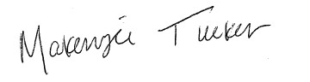

________________________________________
Makenzie Tucker
Worley Fire Protection District
Kootenai County
Administrative Assistant

